

CSCI335 Project
Dr. Bilal Kanso

Fatima Dahwi

In developing this database to enhance the taxi reservation system in my country, I'm focused on providing a comprehensive platform for customers to seamlessly select their preferred taxi company, reserve the suitable car, and get assigned a qualified driver.
This comprehensive database structure aims to create a user-friendly and efficient platform, providing a seamless experience for customers in selecting, reserving, and enjoying taxi services from various companies across the country.

- E R diagram, relational model is designed using ERDPlus tool.
- S QL Code is written using MS SQL Server Mangment Studio

- E
R diagram

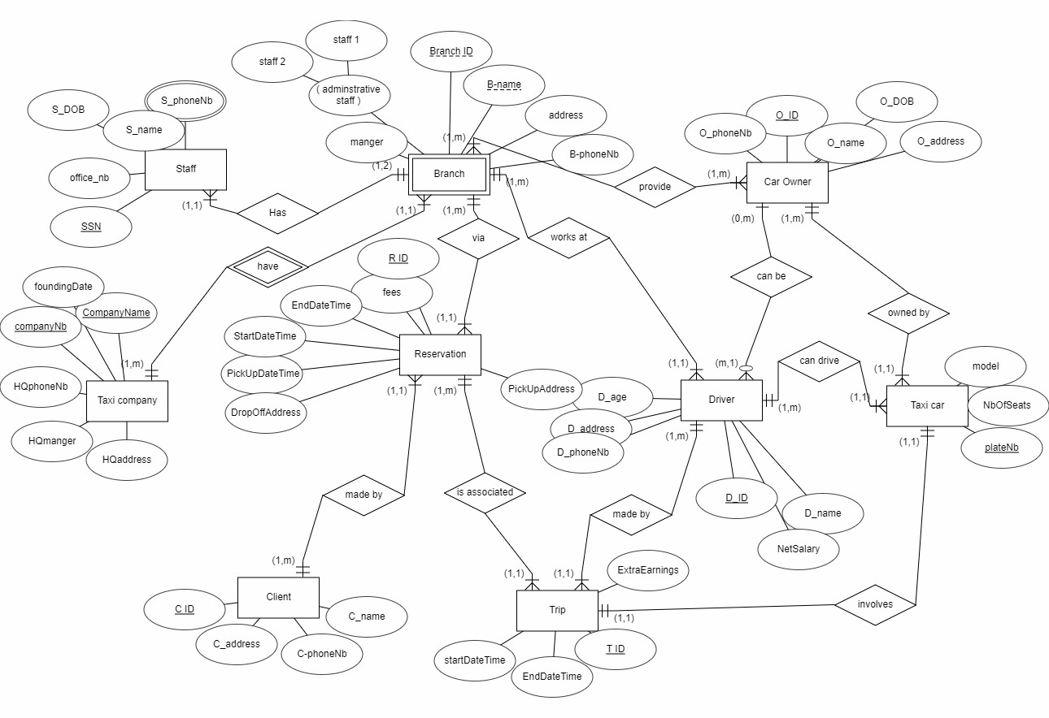
About Taxi Company Entity:

The taxi company entity acts as the central hub that oversees and coordinates the overall taxi service operation, connecting branches, drivers, cars, and reservations.

- Attributes:
- Name: The unique name of the taxi company.
- Registration Number: A unique identifier for the company.
- Founding Date: The date when the company was established.
- HQ Manager: The manager or head of the company's headquarters.
- HQ Address: The address of the company's headquarters.
- HQ Phone Number: The contact phone number for the company's headquarters.

- About Reservation Entity

The reservation entity acts as a central record for managing and tracking taxi services, facilitating efficient coordination between clients, and taxi companies via specific branch.

- Attributes:

- ReservationID: A unique identifier for each
- PickUpDateTime: Date and time for the pick-up.
- PickUpAddress: The location from which the client will be picked up.
- DropOffAddress: The destination address for the drop-off.
- StartDateTime: Start time of the trip.
- EndDateTime: End time of the trip.
- Fees: The cost or fees associated with the reservation

- R
elations

- One taxi car have many branches
- One branch belongs to one company
- One branch has many admins
- Every one admin belong to one branch
- Every car owner can provides many cars
- One branch has many car owners
- Every taxi car can be owned by many car owners
- One car owner can provide many cars
- Car owner can be a driver
- Many drivers can be car owners
- Every driver can drive many cars
- Every taxi car can be driven by one driver
- Every driver work at one branch
- Every branch have many drivers
- Every trip involve one taxi car
- Every car involved in one trip
- Every trip made by one driver
- Every driver make many trips
- Every client make many reservation
- Every reservation made by one client
- Every trip is associated with one reservation
- Every reservation associated for many trips
- Every reservation done via one branch
- Every branch offers many reservations

- R

elational Model

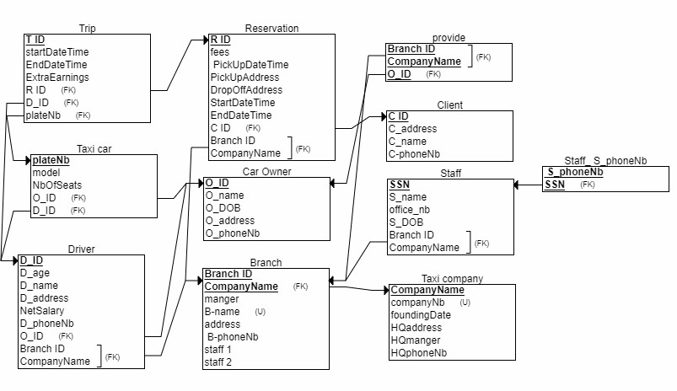
- D

atabase Creation

CREATE TABLE Taxi_company (

companyNb INT NOT NULL, foundingDate Date,
HQaddress VARCHAR(50) NOT NULL, HQmanger VARCHAR(30) NOT NULL, HQphoneNb INT NOT NULL,
PRIMARY KEY (CompanyName), UNIQUE (companyNb)
);

CREATE TABLE Branch (
manger VARCHAR(30) NOT NULL, B_name VARCHAR(30) NOT NULL, addresss VARCHAR(50) NOT NULL,
_B_phoneNb INT NOT NULL, staff_1 VARCHAR(30) NOT NULL, staff_2 VARCHAR(30) NOT NULL, Branch_ID INT NOT NULL,
CompanyName VARCHAR(30) NOT NULL, PRIMARY KEY (Branch_ID, CompanyName),
FOREIGN KEY (CompanyName) REFERENCES Taxi_company(CompanyName), UNIQUE (B_name)
);

CREATE TABLE Staff (
S_name VARCHAR(30) NOT NULL, SSN CHAR(9) NOT NULL,
office_nb INT NOT NULL, S_DOB Date,
Branch_ID INT NOT NULL, CompanyName VARCHAR(30) NOT NULL, PRIMARY KEY (SSN),
FOREIGN KEY (Branch_ID,CompanyName) REFERENCES Branch(Branch_ID,CompanyName)
);

CREATE TABLE Car_Owner (
O_ID INT NOT NULL,
O_name VARCHAR(30) NOT NULL,
O_DOB Date,
O_address VARCHAR(30) NOT NULL,
O_phoneNb INT NOT NULL, PRIMARY KEY (O_ID)
);

CREATE TABLE Driver (
D_age INT NOT NULL,
D_name VARCHAR(30) NOT NULL, D_ID INT NOT NULL,
D_address VARCHAR(50) NOT NULL,
NetSalary INT NOT NULL, D_phoneNb INT NOT NULL, O_ID INT ,
Branch_ID INT NOT NULL,

PRIMARY KEY (D_ID),
FOREIGN KEY (O_ID) REFERENCES Car_Owner(O_ID),
FOREIGN KEY (Branch_ID, CompanyName) REFERENCES Branch(Branch_ID, CompanyName)
);

CREATE TABLE Taxi_car (
plateNb INT NOT NULL, model INT NOT NULL, NbOfSeats_ INT NOT NULL, O_ID INT NOT NULL,
D_ID INT NOT NULL, PRIMARY KEY (plateNb),
FOREIGN KEY (O_ID) REFERENCES Car_Owner(O_ID), FOREIGN KEY (D_ID) REFERENCES Driver(D_ID)
);

CREATE TABLE Client (
C_ID INT NOT NULL,
C_address VARCHAR(50) NOT NULL, C_name VARCHAR(30) NOT NULL,
C_phoneNb INT NOT NULL, PRIMARY KEY (C_ID)
);

CREATE TABLE provide (
Branch_ID INT NOT NULL, CompanyName VARCHAR(30) NOT NULL, O_ID INT NOT NULL,
PRIMARY KEY (Branch_ID, CompanyName, O_ID),
FOREIGN KEY (Branch_ID, CompanyName) REFERENCES Branch(Branch_ID, CompanyName), FOREIGN KEY (O_ID) REFERENCES Car_Owner(O_ID)
);

CREATE TABLE Reservation (
fees INT NOT NULL, R_ID INT NOT NULL,
_PickUpDate Date, pickUPTime INT NOT NULL,
PickUpAddress VARCHAR(50) NOT NULL, DropOffAddress VARCHAR(50) NOT NULL, StartDateTime INT NOT NULL, EndDateTime INT NOT NULL,
C_ID INT NOT NULL, Branch_ID INT NOT NULL,
CompanyName VARCHAR(30) NOT NULL, PRIMARY KEY (R_ID),
FOREIGN KEY (C_ID) REFERENCES Client(C_ID),
FOREIGN KEY (Branch_ID, CompanyName) REFERENCES Branch(Branch_ID, CompanyName)
);

CREATE TABLE Trip (
startDateTime INT NOT NULL, EndDateTime INT NOT NULL,

ExtraEarnings INT NULL, T_ID INT NOT NULL,
R_ID INT NOT NULL, D_ID INT NOT NULL,
plateNb INT NOT NULL, PRIMARY KEY (T_ID),
FOREIGN KEY (R_ID) REFERENCES Reservation(R_ID), FOREIGN KEY (D_ID) REFERENCES Driver(D_ID),
FOREIGN KEY (plateNb) REFERENCES Taxi_car(plateNb)
);

CREATE TABLE Staff S_phoneNb (
_S_phoneNb INT NOT NULL, SSN CHAR(9) NOT NULL,
PRIMARY KEY (_S_phoneNb, SSN),
FOREIGN KEY (SSN) REFERENCES Staff(SSN)
);

- N

ormalization

- Taxi company table already in 3NF
- Branch table already in 3NF
- Staff table already in 3NF
- Car owner table already in 3NF
- Driver table already in 3NF
- Client table already in 3NF
- Taxi car table already in 3NF
- Reservation table already in 3NF
- Provide table already in 3NF
- Staff S_phoneNb already in 3NF
- Trip table already in 3NF

- I

nsertion of Data

insert into Taxi_company values('hammoud',1,'10-NOV-27','hamra','Ali',70494426); insert into Taxi_company values('rammel',2,'12-FEB-23','dahye','mhmd',78861374); insert into Taxi_company values('abdallah',3,'8-MAR-24','chiyeh','Ali',76543526); insert into Taxi_company values('RIVOLOI',4,'1-MAy-20','nabatieh','mahmoud',71342567);
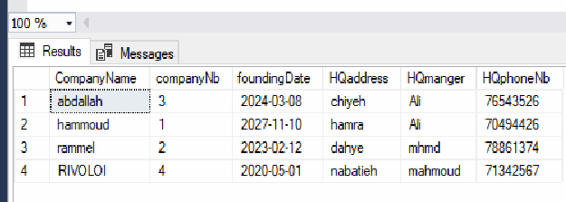

insert into Branch values('ali','b1','nabatieh',70494427,'basel','bassam',1,'hammoud'); insert into Branch values('abbas','b2','beqaa',70494428,'batoul','hosam',2,'rammel'); insert into Branch values('alaa','b3','beirut',70494429,'baraa','fatima',3,'abdallah'); insert into Branchvalues('zahraa','b4','nabatieh',70494430,'baker','zainab',4,'RIVOLOI'); insert into Branch values('alaa','b5','zahle',70494627,'basel','bassam',5,'hammoud');
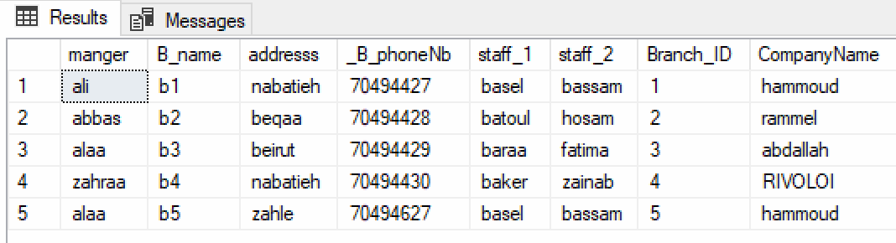

insert into Staff values('basel',1231231,123,'12-NOV-2000',1,'hammoud'); insert into Staff values('bassam',1231232,124,'2-MAR-1999',1,'hammoud'); insert into Staff values('batoul',1231233,125,'5-APRIL-2001',2,'rammel'); insert into Staff values('hosam',1231234,126,'19-FEB-1990',2,'rammel'); insert into Staff values('baraa',1231235,127,'12-OCT-1992',3,'abdallah'); insert into Staff values('fatima',1231236,128,'14-MAY-1996',3,'abdallah'); insert into Staff values('zainab',1231237,129,'25-JUNE-2000',4,'RIVOLOI'); insert into Staff values('baker',1231238,120,'23-JULT-1996',4,'RIVOLOI');

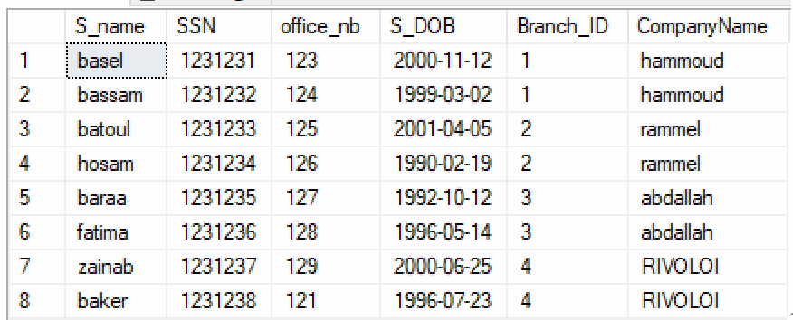

insert into Car_Owner values (191,'moataz','19-FEB-1970','nabatieh',78861374); insert into Car_Owner values (192,'saleh','1-MAY-1972','Beirut',78861375); insert into Car_Owner values (193,'hsein','10-MAY-1977','beqaa',78861376); insert into Car_Owner values (194,'yaser','21-OCT-1980','baalbak',78861377); insert into Car_Owner values (195,'mokhtar','30-NOV-1990','zahle',78861378); insert into Car_Owner values (196,'ahmad','28-FEB-1968','nabatieh',78861379); insert into Car_Owner values (197,'aziz','3-JUNE-1985','beirut',78861370);
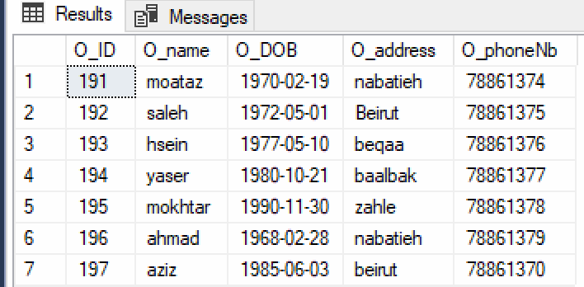

insert into Driver values(20,'mhmd baker',12345,'kfarsir',2500,71234567,null,1,'hammoud'); insert into Driver values(21,'ali hammoud',12346,'sir',2000,71234568,192,2,'rammel'); insert into Driver values(22,'mhmd reslan',12347,'adshit',1500,71234569,null,3,'abdallah'); insert into Driver values(24,'zakaria dahwi',12349,'dahye',1900,71234564,null,4,'RIVOLOI'); insert into Driver values(23,'ali baraket',12348,'harouf',2500,71234561,193,1,'hammoud');

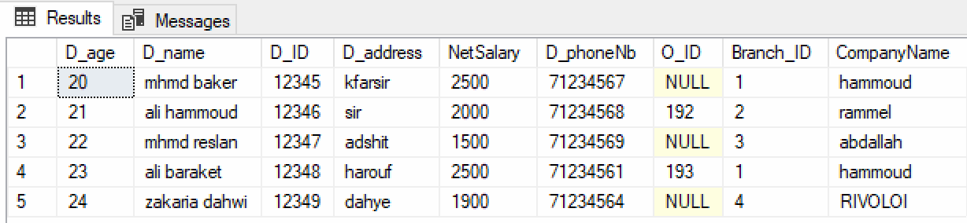

insert into Taxi_car values(45671,2005,4,191,12345); insert into Taxi_car values(45672,2009,5,192,12346); insert into Taxi_car values(45673,2019,7,193,12347); insert into Taxi_car values(45674,2023,8,194,12348); insert into Taxi_car values(45675,2024,6,195,12349); insert into Taxi_car values(45676,2020,4,196,12345);

insert into Taxi_car values(45677,2020,4,196,12346); insert into Taxi_car values(45697,2020,8,196,12345);
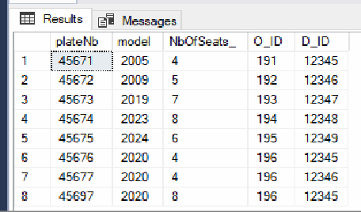

insert into Client values(890,'akkar','talal',03696281); insert into Client values(891,'zefta','kawkab',03696282); insert into Client values(892,'tripol','youmna',03696283); insert into Client values(893,'tyre','yesra',03696284); insert into Client values(894,'anjar','mahfouz',03696285); insert into Client values(895,'kheyam','ikram',03696286);

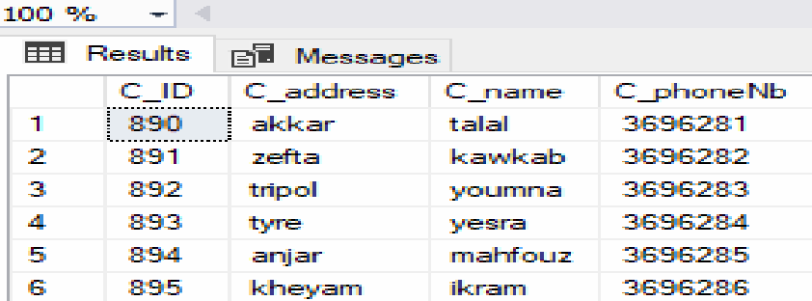

insert into provide values(1,'hammoud',191); insert into provide values(2,'rammel',192); insert into provide values(3,'abdallah',193); insert into provide values(4,'RIVOLOI',194); insert into provide values(1,'hammoud',194); insert into provide values(2,'rammel',196);

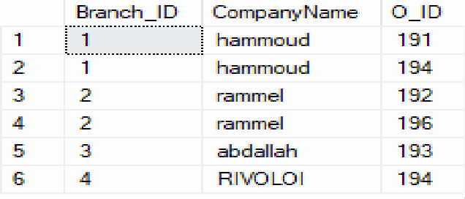

insert into Reservation values(200,51,'12-APR-2023',8,'nabatieh','beirut',8,12,890,1,'hammoud'); insert into Reservation values(250,52,'1-APR-2023',5,'nabatieh','akkar',5,11,891,1,'hammoud'); insert into Reservation values(300,53,'30-MAR-2023',2,'nabatieh','saida',2,3,895,2,'rammel'); insert into Reservation values(150,54,'28-FEB-2023',1,'beirut','tyre',1,4,894,3,'abdallah'); insert into Reservation values(200,55,'2-MAY-2023',8,'kfarsir','beirut',8,11,892,4,'RIVOLOI'); insert into Reservation values(100,56,'9-NOV-2023',10,'nabatieh','sour',10,11,893,1,'hammoud');

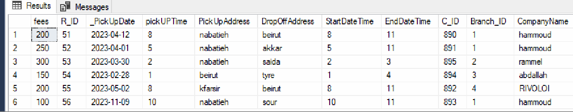

insert into Trip values(8,11,NULL,990,51,12345,45671); insert into Trip values(5,11,NULL,991,52,12346,45672); insert into Trip values(2,3,NULL,992,53,12347,45673); insert into Trip values(1,4,NULL,993,54,12348,45674); insert into Trip values(8,11,NULL,994,55,12349,45675); insert into Trip values(10,11,NULL,995,56,12348,45674);

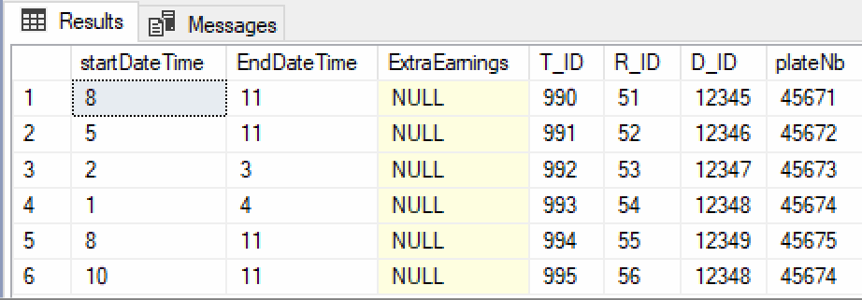

insert into Staff S_phoneNb values(81988608,1231231); insert into Staff S_phoneNb values(81988609,1231231); insert into Staff S_phoneNb values(81988601,1231233); insert into Staff S_phoneNb values(81988602,1231234);

insert into Staff S_phoneNb values(81988603,1231235); insert into Staff S_phoneNb values(81988604,1231236); insert into Staff S_phoneNb values(81988605,1231237); insert into Staff S_phoneNb values(81988606,1231238); insert into Staff S_phoneNb values(81980608,1231234); insert into Staff S_phoneNb values(81988607,1231236);
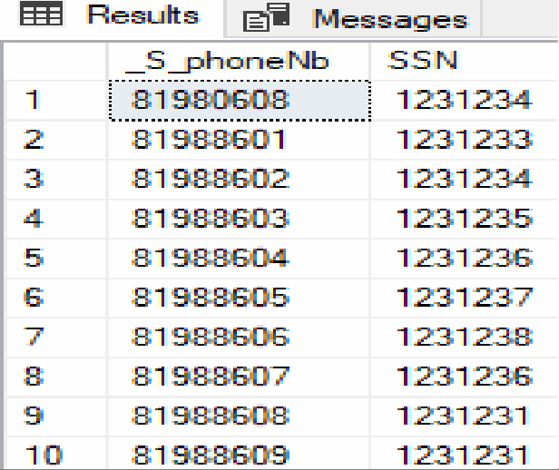

- Q
ueries

  - Update the name of 2 branches of one company:
UPDATE Branch set B_name='bh' where Branch_ID=1 and CompanyName='hammoud' UPDATE Branch set B_name='bm' where Branch_ID=5 and CompanyName='hammoud'

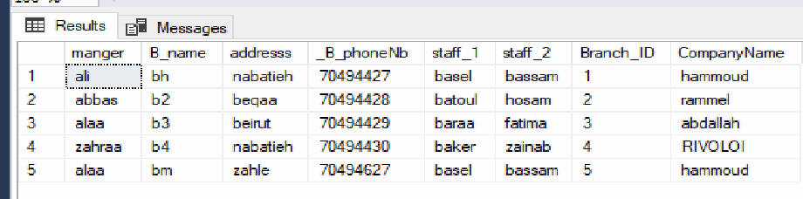

  - list the name and Id of drivers that associated with branch 2

select D_name,D_ID from Driver
where Branch_ID=2
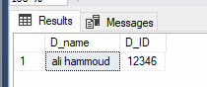

list the name of drivers who are less than
233 year in all companies
select * from Driver
where D_age < 23;
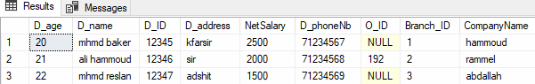

list of mangers and phone number who work in specific company
select HQmanger ,HQphoneNb from Taxi_company
where CompanyName='abdallah' or CompanyName='rammel'
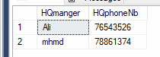

list of different address for drivers

select distinct D_address from Driver
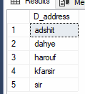

list the reservation that has pickup time between 5&11
select*
from Reservation
where pickUPTime between 5 and 11
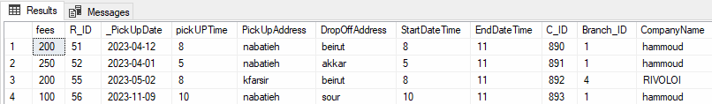

list all the details of drivers who has first name is mhmd

select* from Driver
where D_name Like 'mhmd%'
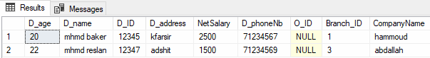

update the extra earning for some drivers
update Trip

set ExtraEarnings  where T_ID=990; | = | 50
update Trip  set ExtraEarnings | = | 110
where T_ID=991;
update Trip  set ExtraEarnings | = | 75
where T_ID=993;
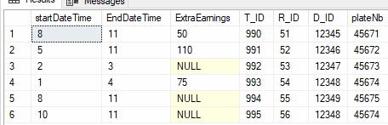

list of trips with extra earning
select* from Trip
where ExtraEarnings IS NOT NULL;
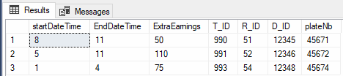

list of all reservation belong to branch 1 of company ‘hammoud’
select*
from Reservation
where Branch_ID = 1 and CompanyName = 'hammoud';
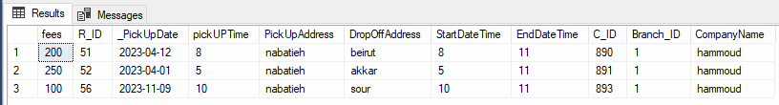

list of branches (ID & company name) with
more than 1 staff
select Branch_ID, CompanyName, count(*) nb_of_staffs from Staff
group by Branch_ID, CompanyName having count(*) >1;
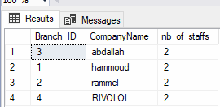

list of car owners providing more than 1 car and the total number of cars they provide
select O_ID, count(*) total_nb_cars from provide
group by O_ID
having COUNT(*) > 1;
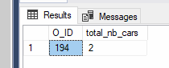

list of info about trips including details about driver and the car
select *
from Trip T, Driver D, Taxi_car TC
where T.D_ID = D.D_ID and T.plateNb = TC.plateNb;
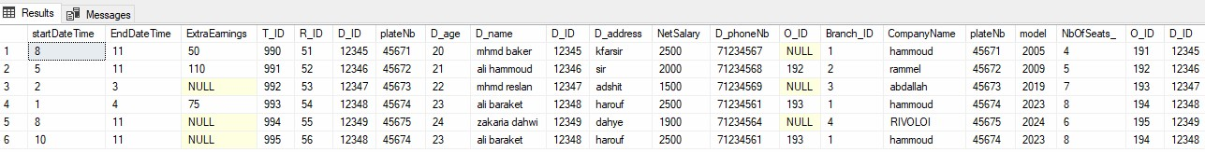

list of reservations and the clients how made
this reservation
select*
from Trip T, Reservation R where T.R_ID = R.R_ID;


select the details(SSN,phoneNb) of staff with SSN=1231231
select _S_phoneNb ,SSN from Staff S_phoneNb where SSN=1231231
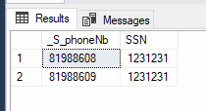

listof cars that has more than four seats
select plateNb from Taxi_car where NbOfSeats_>4
